

Expense Tracker Application

MINI PROJECT REPORT
Submitted by

Sampreeth Krishna Udupa S - 9124128046
Saipooja - 9124129045
Ryan Daniel Paul - 9124128044

in the partial fulfilment for the award of the degree
of

BACHELOR OF ENGINEERING

IN

COMPUTER SCIENCE AND ENGINEERING (CYBER SECURITY)

KCG COLLEGE OF TECHNOLOGY, KARAPAKKAM

(AUTONOMOUS)



BONAFIED CERTIFICATE

Certified that this Mini Project report titled EXPENSE TRACKER APP is the Bonafide work of SAMPREETH KRISHNA UDUPA S (9124128046), SAIPOOJA (9124129045), RYAN DANIEL PAUL (9124128044) who carried out the mini project to fulfil the requirements of the course “23CS301 and OBJECT-ORIENTED PROGRAMMING” .

SIGNATURE SIGNATURE

Dr. G.G. Gokilam Dr. S. Roselin Mary
SUPERVISOR HEAD OF THE DEPARTMENT
Assistant Professor Professor
Dept. of CSE (Cyber Security) Dept. of CSE (Cyber Security)
KCG College of Technology KCG College of Technology
Karapakkam,Chennai Karapakkam,Chennai

TABLE OF THE CONTENTS

CHAPTER NO. | TITLE | PAGE NO.
 | ABSTRACT | 1
1. | INTRODUCTION  1.1 OVERVIEW OF THE PROJECT  1.2 OBJECTIVES | 2
2. | PROJECT DESCRIPTION | 3
3. | ANALYSIS  3.1 FUNCTIONAL REQUIREMENTS  3.2 NON-FUNCTIONAL REQUIREMENTS  3.3 HARDWARE SPECIFICATION  3.4 SOFTWARE SPECIFICATION  3.5 EXECUTION ENVIRONMENT | 4
4. | DESIGN  4.1 OVERALL FLOW CHART  4.2 ALGORITHM DESIGN | 6
5. | MODULE DESCRIPTION  5.1 TRANSACTION MODULE  5.2 DASHBOARD MODULE | 8
6. | CONCLUSION | 10
7. | APPENDIX  APPENDIX A – Code Snippets  APPENDIX B – Application File Tree  APPENDIX C – Output Screenshots | 11

ABSTRACT

Financial management is a vital aspect of everyday life, and with the increasing number of digital transactions, keeping track of expenses across multiple accounts can become challenging. The Expense Tracker application is designed to simplify personal finance management by providing a clear, interactive, and real-time overview of spending patterns and account balances. Developed using JavaFX, the system delivers a visually intuitive interface that integrates essential tools for logging, categorizing, and analyzing expenses.
The application primarily operates through two virtual accounts — Bank and GPay — and allows users to record expenses by specifying the amount, category, and description. Each transaction dynamically updates account balances and visual summaries, including a pie chart representing category-wise spending distribution. All data is managed through an efficient backend system that ensures instant reflection of updates in the user interface.
This project demonstrates how modern graphical tools and structured programming concepts can be employed to build an effective, user-friendly financial management solution. It not only supports better tracking of day-to-day expenditures but also encourages responsible financial planning and awareness.

CHAPTER 1

INTRODUCTION

  - OVERVIEW OF THE PROJECT

The Expense Tracker project focuses on managing and monitoring personal financial transactions through a simple, interactive desktop application built using JavaFX and JDK 21. It allows users to record, categorize, and visualize their expenses in real time, providing better control over their financial activities.
The system maintains two virtual accounts — Bank Account and GPay Account — each initialized with a predefined balance. Users can add new expenses by selecting the category, entering the amount, and providing a short description. Every transaction instantly updates the account balance and displays the details in a tabular format.
An interactive dashboard shows the distribution of expenses through a circular pie chart, offering a quick visual summary of spending habits. The interface is designed to be simple, intuitive, and responsive, ensuring a smooth user experience for all types of users.

1.2 OBJECTIVES

- To design a simple and user-friendly personal expense tracking application.
- To provide real-time updates of account balances after each transaction.
- To categorize expenses such as Food, Travel, Shopping, Utilities, Bills, and Miscellaneous.
- To visually represent spending patterns using a circular (pie) chart.
- To demonstrate the use of JavaFX for building interactive desktop applications.
- To encourage better financial awareness and organized expense management.

CHAPTER 2

PROJECT DESCRIPTION

The Expense Tracker project is a simple and effective system designed to help users manage their day-to-day financial transactions. It provides an easy way to record, categorize, and analyze expenses through an interactive JavaFX-based desktop interface. The main aim of this project is to promote better financial awareness and encourage responsible spending by giving users a clear picture of their financial activities in real time.
The system maintains two virtual accounts — a Bank Account and a GPay Account — each initialized with a starting balance. Users can record new expenses by entering the amount, selecting the payment source and category, and providing a short description. Once a payment is made, the application automatically deducts the amount from the selected account and logs the transaction instantly.
The project consists of two main modules:
- Transaction Module: This section enables users to input payment details such as amount, category, account type, and description. Upon confirming the payment, the system updates the corresponding account balance and records the expense in the transaction history table.
- Dashboard Module: This section provides a visual summary of all expenses through a circular (pie) chart, showing how funds are distributed across categories such as Food, Travel, Shopping, Utilities, Bills, and Miscellaneous. It also displays the updated balances of both accounts and lists all transactions with date and time details.
The user interface is designed to be simple, intuitive, and responsive, ensuring ease of use for all users. Each component of the application is structured for clarity, with real-time updates and visual elements that make tracking expenses more engaging.

CHAPTER 3

ANALYSIS

  - Functional Requirements

- Transaction Module:
Allows users to record new expenses by entering the amount, selecting the category, and choosing the payment source (Bank or GPay).
Automatically deducts the entered amount from the selected account balance.
Displays the updated balances for both accounts in real time.
Stores the expense details including date, category, amount, and description.

- Dashboard Module:
Displays all recorded transactions in a tabular format for easy review.
Generates a circular pie chart representing the percentage of expenses under each category.
Provides a clear view of spending distribution and remaining balances.
Refreshes dynamically whenever a new transaction is made.

3.2 Non-Functional Requirements
- Usability: Designed with a simple and user-friendly JavaFX interface for ease of use.
- Portability: Runs on any system with Java JDK 21 and JavaFX SDK installed.
- Reliability: Ensures accurate balance updates and consistent data display.
- Maintainability: Structured with modular Java classes, making it easy to update or add new features.
- Performance: Provides instant response to user actions through event-driven programming.
- Scalability: Can be extended with database integration and additional account types.

3.3 Hardware Specification
- Processor: Intel Core i3 or higher
- RAM: Minimum 4 GB (8 GB recommended)
- Storage: At least 200 MB of free space
- Display: Minimum 1366×768 resolution

3.4 Software Specification
- Operating System: Windows / Linux / macOS
- Languages Used: Java (JDK 21)
- Development Tools:
  - Code Editor: VS Code
  - JDK Path: Configured for Java 21
  - Build Tool: Command Line (javac, java) or IDE build system
3.5 Execution Environment
- Platform: Desktop-based application (JavaFX GUI)
- Execution Mode: Runs locally using the Java Runtime Environment (JRE 21)
- Frontend: JavaFX interface with FXML layout and CSS styling
- Backend: Java classes handling logic, data binding, and chart visualization
- Tested On: Windows 10/11 with JDK 21 and JavaFX SDK 21.0.8

CHAPTER 4

DESIGN

4.1 OVERALL FLOW CHART
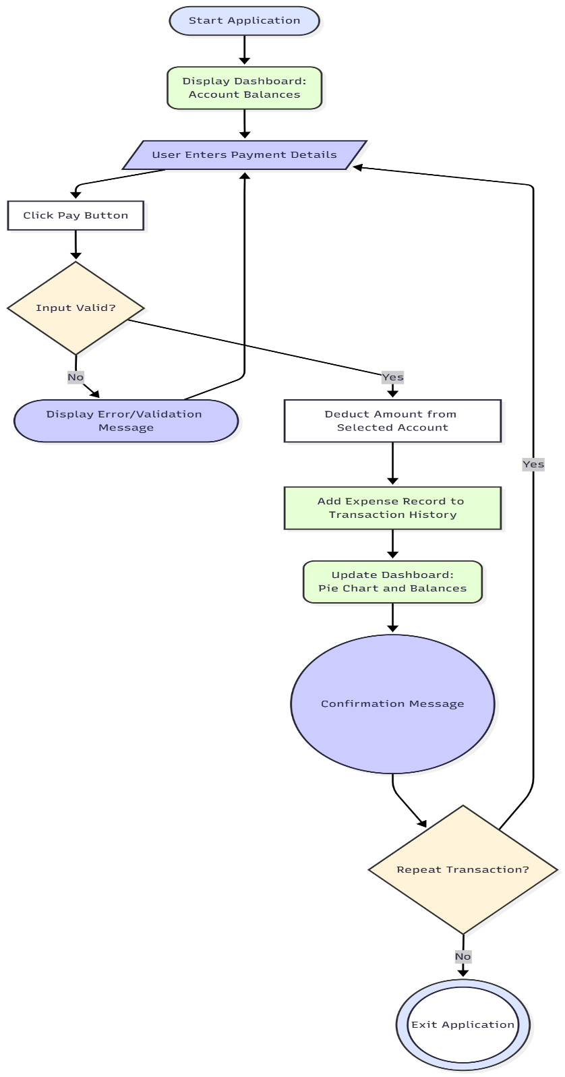

4.2 Expense Tracker – Algorithm Design

The project records user expenses, updates account balances, and visually represents
spending data using JavaFX. The logic ensures that every transaction is instantly reflected in
both the account summary and expense chart.

4.2.1 Transaction Processing Steps

- User inputs amount, category, account type, and description.
- The system checks if the amount is valid and if sufficient funds are available.
- If valid, deduct the entered amount from the respective account balance.
- Create a new expense record with timestamp, category, and amount.
- Add the record to the expense list and transaction table.
- Update the circular (pie) chart to reflect the latest spending pattern.
- Display a success message confirming the transaction.

4.2.2 Dashboard Update Steps
- Retrieve all recorded expenses.
- Group expenses based on categories (Food, Travel, Shopping, Utilities, Bills, Misc).
- Calculate total spent under each category.
- Generate pie chart segments based on category totals.
- Display updated account balances and transaction details.
- Refresh the dashboard automatically after every new transaction.

CHAPTER 5

MODULE DESCRIPTION
5.1 Transaction Module
The Transaction Module allows the user to record and manage expenses easily. It serves as the core functional part of the system where financial entries are made and immediately reflected in the dashboard. Users can select the payment source (Bank or GPay), choose a spending category, enter the amount, and add a short description for each transaction. Upon confirmation, the system updates balances and logs the transaction automatically.
Steps:
• The user enters the amount, category, and description of the expense.
• The system validates the amount and checks the selected account’s available balance.
• If sufficient funds exist, the amount is deducted from the respective account.
• A new expense record is created with details such as timestamp, category, account name, and amount.
• The record is added to the transaction table, and the balances are updated in real time.
• A confirmation message is displayed, indicating successful transaction logging.

5.2 Dashboard Module
The Dashboard Module provides a real-time visual and tabular representation of all expenses and account balances. It includes an interactive pie chart for category-wise expense visualization and a table view for detailed transaction listings. This helps users quickly assess where and how their money is being spent.

Steps:
• On application start, the dashboard displays current balances of both accounts.
• The system retrieves all recorded expenses and groups them by category.
• A pie chart is generated showing the percentage share of each expense category.
• All expenses are displayed in a table with date, category, amount, account, and description.
• Whenever a new transaction is added, both the table and pie chart refresh automatically.
• The dashboard remains interactive, ensuring that users always view up-to-date financial data.

CHAPTER 6

CONCLUSION

The Expense Tracker project successfully demonstrates how personal financial management can be simplified through a user-friendly and interactive desktop application. By utilizing JavaFX and object-oriented programming principles, the system effectively tracks expenses, updates account balances, and provides real-time visual insights into spending habits.
The application’s dual-account setup (Bank and GPay) allows users to simulate real-world financial activity, while features like instant balance updates, categorized expense logging, and a circular pie chart ensure both clarity and ease of understanding. The intuitive interface makes it accessible to users with minimal technical knowledge, while the modular code structure promotes easy maintenance and expansion.
Overall, this project highlights the efficient use of Java technologies in developing practical financial tools. It serves as a strong foundation for further enhancements such as database integration, budget tracking, data export, and cloud synchronization. The Expense Tracker thus combines functionality, usability, and clarity—offering a reliable and organized approach to managing personal finances.

CHAPTER 7

APPENDICES

Appendix A – Code Snippets

1️⃣ MainApp.java

public class MainApp extends Application {
@Override
public void start(Stage primaryStage) throws Exception {
FXMLLoader loader = new FXMLLoader(getClass().getResource("/dashboard.fxml"));
Parent root = loader.load();
Scene scene = new Scene(root);
primaryStage.setTitle("Expense Tracker");
primaryStage.setScene(scene);
primaryStage.show();
}

public static void main(String[] args) {
launch(args);
}
}

2️⃣ DashboardController.java – Main Logic Controller

@FXML
private void handleAddExpense() {
String description = descriptionField.getText();
double amount = Double.parseDouble(amountField.getText());
String category = categoryChoice.getValue();
String accountType = accountChoice.getValue();

Expense expense = new Expense(description, amount, category, accountType);
expenseManager.addExpense(expense);

updatePieChart();
updateBalanceLabels();

clearFields();
}

3️⃣ Expense.java – Model Class

public class Expense {
private String description;
private double amount;
private String category;
private String accountType;

public Expense(String description, double amount, String category, String accountType) {
this.description = description;
this.amount = amount;
this.category = category;
this.accountType = accountType;
}

// Getters
public String getDescription() { return description; }
public double getAmount() { return amount; }
public String getCategory() { return category; }
public String getAccountType() { return accountType; }
}

4️⃣ ExpenseManager.java – Business Logic Layer

public class ExpenseManager {
private List<Expense> expenses = new ArrayList<>();
private FakeAccount bankAccount = new FakeAccount("Bank", 10000);
private FakeAccount gpayAccount = new FakeAccount("GPay", 5000);

public void addExpense(Expense expense) {
expenses.add(expense);
if (expense.getAccountType().equals("Bank")) {
bankAccount.deduct(expense.getAmount());
} else {
gpayAccount.deduct(expense.getAmount());
}
}

public double getTotalExpenses() {
return expenses.stream().mapToDouble(Expense::getAmount).sum();
}

public FakeAccount getBankAccount() { return bankAccount; }
public FakeAccount getGpayAccount() { return gpayAccount; }
}

5️⃣ FakeAccount.java – Account Simulation Class

public class FakeAccount {
private String name;
private double balance;

public FakeAccount(String name, double balance) {
this.name = name;
this.balance = balance;
}

public void deduct(double amount) {
balance -= amount;
}

public double getBalance() {
return balance;
}

public String getName() {
return name;
}
}

Appendix B – Application File Tree

C:\Expense Tracker\
│
├─ src\
│ └─ com\example\expensetracker\
│ ├─ MainApp.java
│ ├─ DashboardController.java
│ ├─ Expense.java
│ ├─ ExpenseManager.java
│ └─ FakeAccount.java (Account Demonstrators)
│
├─ resources\
│ ├─ dashboard.fxml
│ └─ style.css
│
└─ lib\
└─ javafx-sdk-21.0.8\
└─ lib\ ← contains all JavaFX .jar files

Appendix C – Output Screenshot

